CodeDJ Artifact for ECOOP 2021

Our artifact is packaged as a VirtualBox VM. Download the VM (ecoop-artifact.ova) from the main url:
http://147.32.233.132/codedj-artifact-ecoop21/
and then use VirtualBox’ Import Appliance feature, which adds the VM to the list of your virtual machines. At this point you can also customize the number of CPUs and RAM used in the VM settings. The initial configuration is 4 cores and 8GB RAM. While the cores are enough, we highly recommend upgrading the memory if you can. Our tool is expected to run on servers and while 8GB is possibly barely enough to run the artifact item by item, the limit is extremely tight.
Start the artifact and and Ubuntu 20.04 LTS will be booted with default user with the following credentials:
Username: ecoop
Password: ecoop
Most of the files necessary to run our artifact are already provided inside the VM. We have excluded the full dataset from the VM as it would considerably increase the download, but we do provide the option to download it separately.
The artifact itself is described in detail in R notebook files (a mixture of text & code, similar to jupyter notebooks for Python). These are best viewed in RStudio, which is also preloaded and can be launched by clicking on the top left icon in the Ubuntu taskbar:
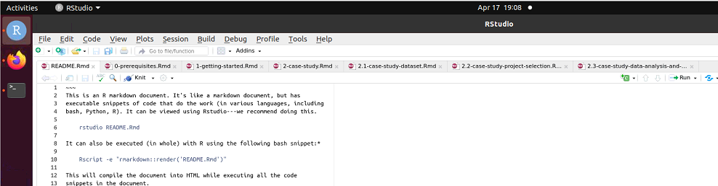
All notebooks of the artifact are opened by default. Start with the leftmost README.Rmd which then provides detailed information on the artifact organization and will guide you through the rest of the artifact.
When working with R notebooks, to execute particular code block you can either click on the green play icon on the right, or you can use any of the following execution modes & shortcuts:

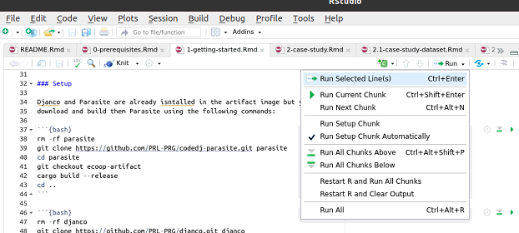

Thank you very much for evaluating our artifact!

